Test Case: runTestMultipleTimes
Step 1 - Enter username and password and click to button Enter : Credentials Entered
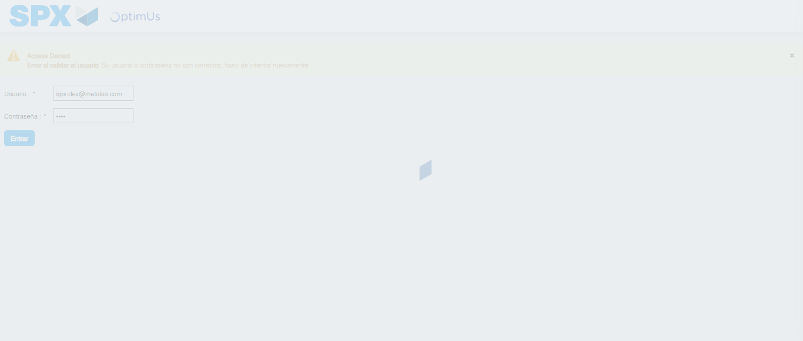Image file-name: QC_Testing-runTestMultipleTimes-nov. 25 2025, 03 54 19 p. m.

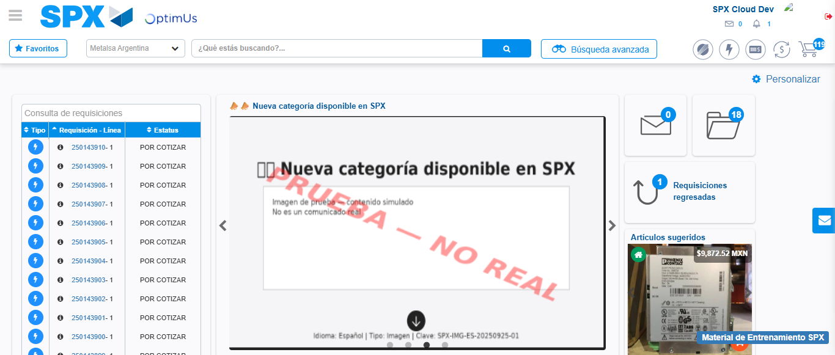Image file-name: QC_Testing-runTestMultipleTimes-nov. 25 2025, 03 55 58 p. m.

Step 2 - Select to UEN and Access to Spot Buy Requisitions : UEN Correctly selected and Correct access
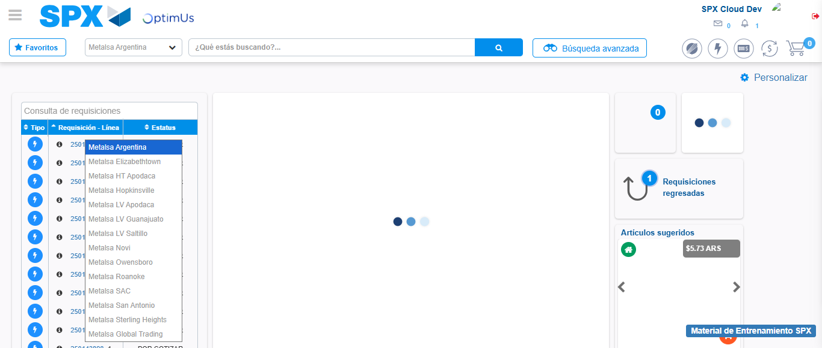Image file-name: QC_Testing-runTestMultipleTimes-nov. 25 2025, 03 54 23 p. m.

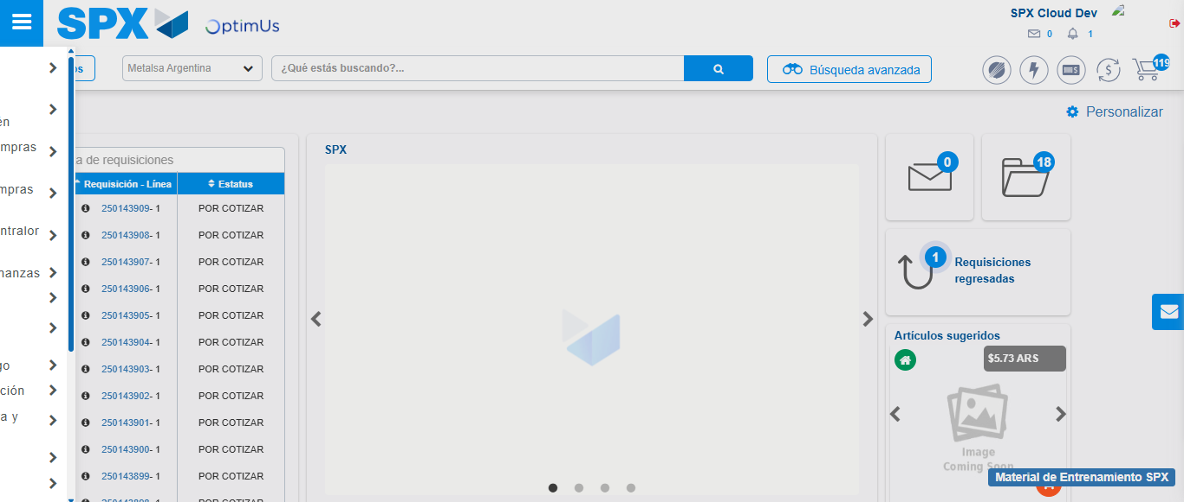Image file-name: QC_Testing-runTestMultipleTimes-nov. 25 2025, 03 54 24 p. m.

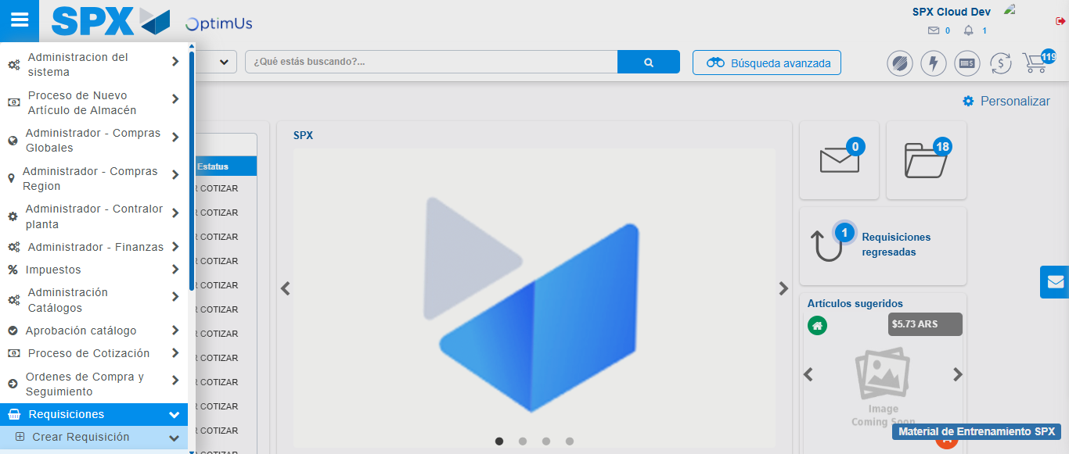Image file-name: QC_Testing-runTestMultipleTimes-nov. 25 2025, 03 54 25 p. m.

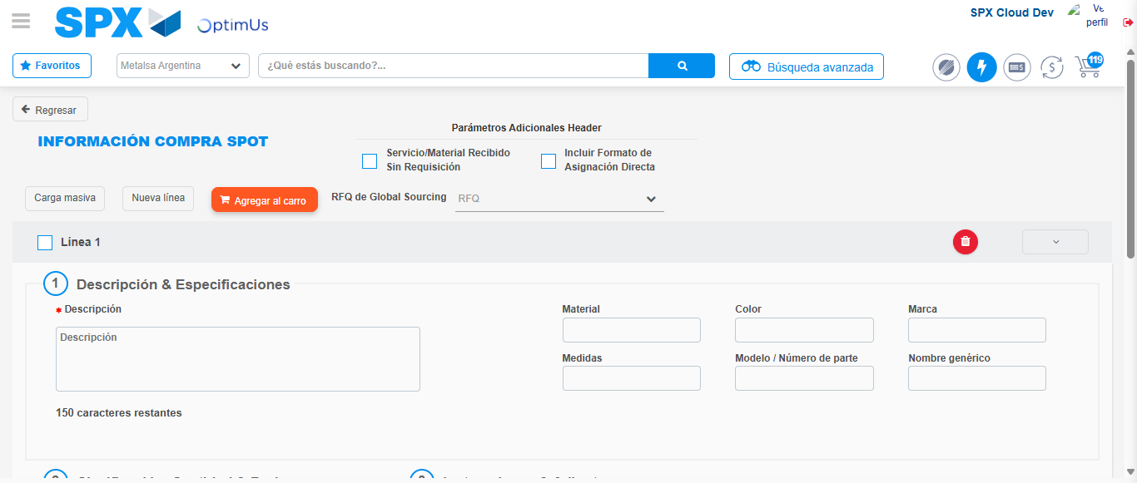Image file-name: QC_Testing-runTestMultipleTimes-nov. 25 2025, 03 54 29 p. m.

Image file-name: QC_Testing-runTestMultipleTimes-nov. 25 2025, 03 55 58 p. m.

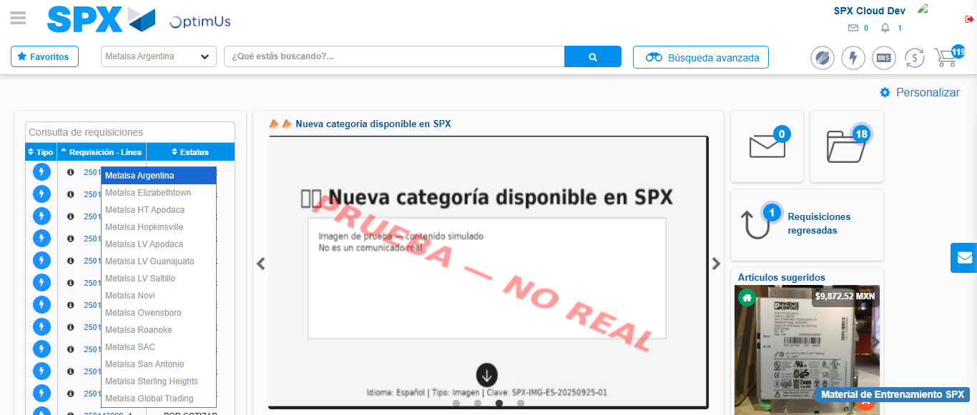Image file-name: QC_Testing-runTestMultipleTimes-nov. 25 2025, 03 55 59 p. m.

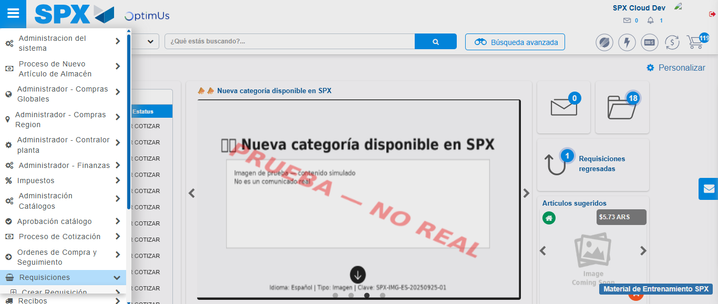Image file-name: QC_Testing-runTestMultipleTimes-nov. 25 2025, 03 56 00 p. m.

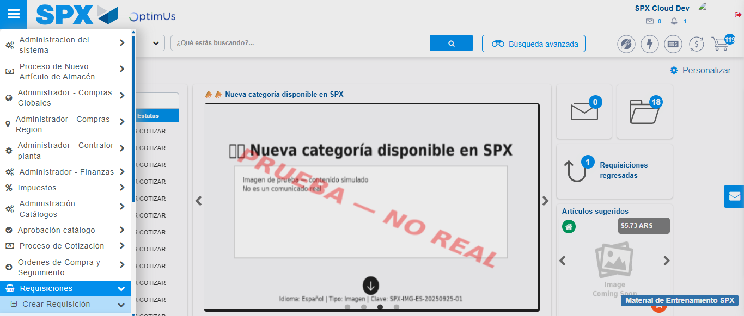Image file-name: QC_Testing-runTestMultipleTimes-nov. 25 2025, 03 56 01 p. m.

Image file-name: QC_Testing-runTestMultipleTimes-nov. 25 2025, 03 56 04 p. m.

Step 3 - Data Capture Spot Buy Requisition : Data captured correctly
Image file-name: QC_Testing-runTestMultipleTimes-nov. 25 2025, 03 54 29 p. m.

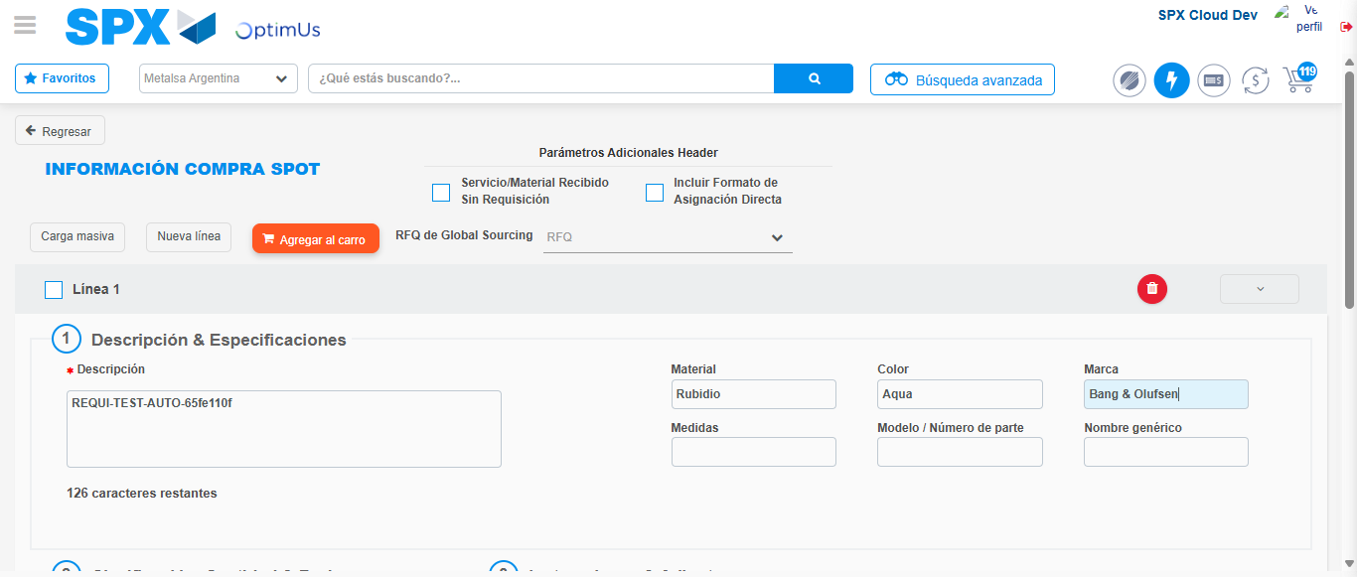Image file-name: QC_Testing-runTestMultipleTimes-nov. 25 2025, 03 54 30 p. m.

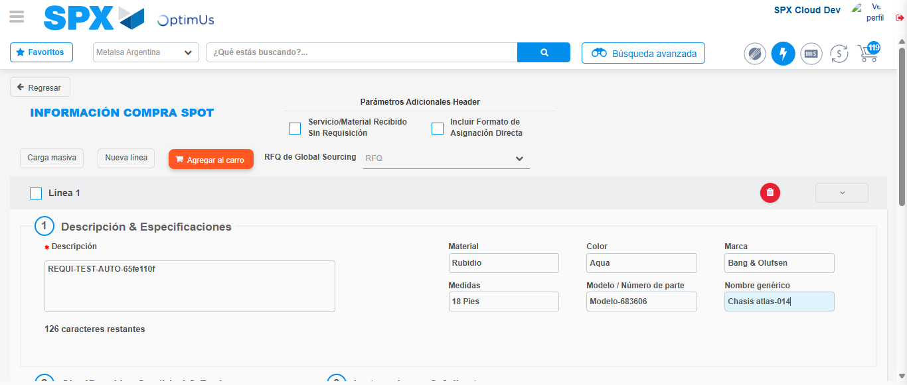Image file-name: QC_Testing-runTestMultipleTimes-nov. 25 2025, 03 54 31 p. m.

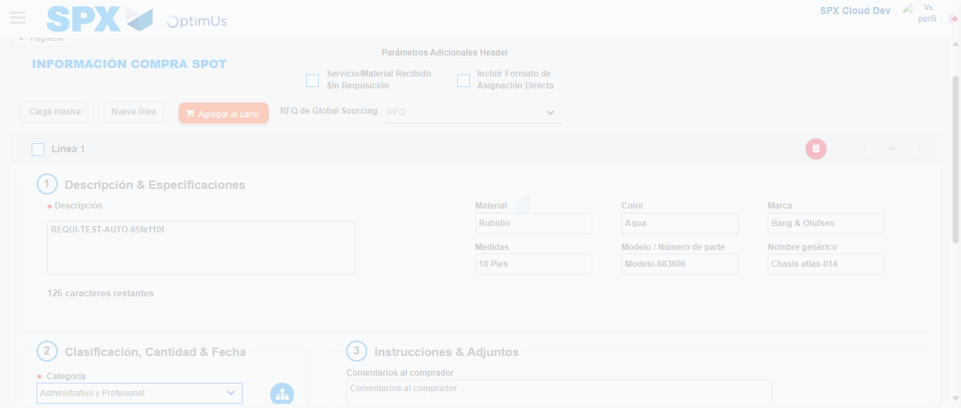Image file-name: QC_Testing-runTestMultipleTimes-nov. 25 2025, 03 54 32 p. m.

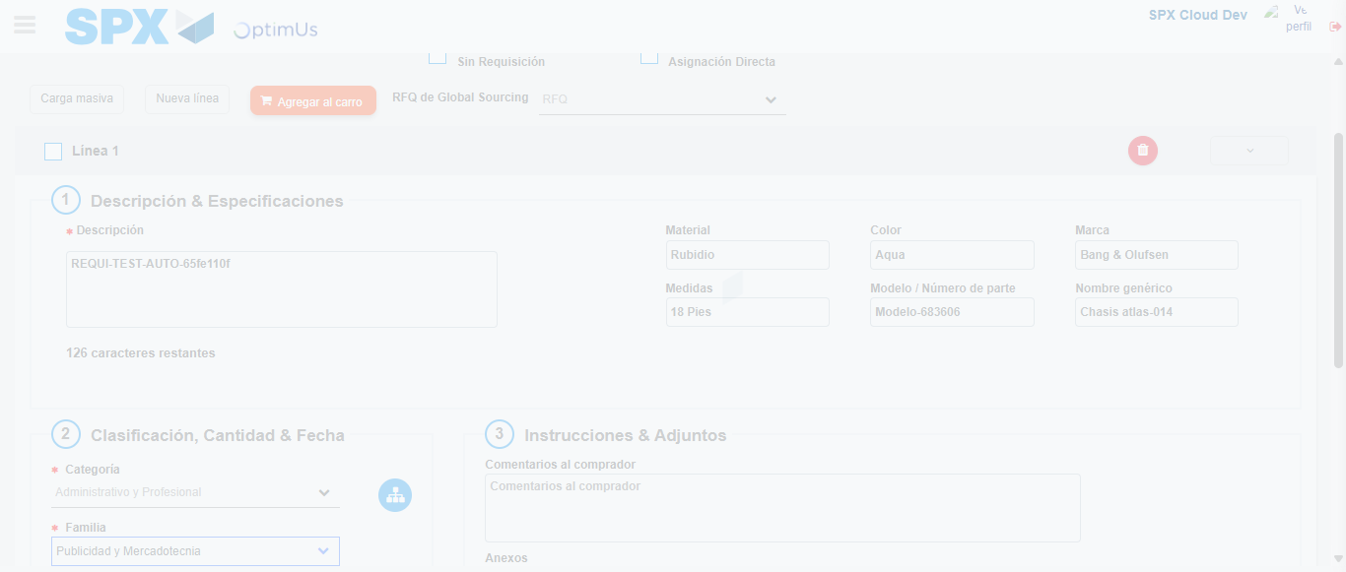Image file-name: QC_Testing-runTestMultipleTimes-nov. 25 2025, 03 54 33 p. m.

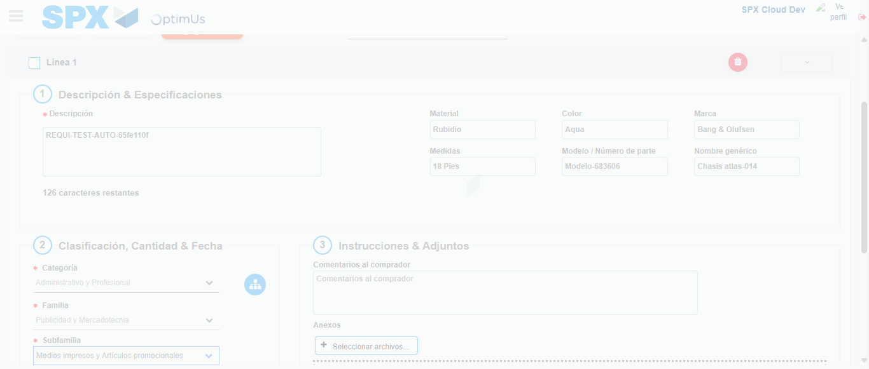Image file-name: QC_Testing-runTestMultipleTimes-nov. 25 2025, 03 54 34 p. m.

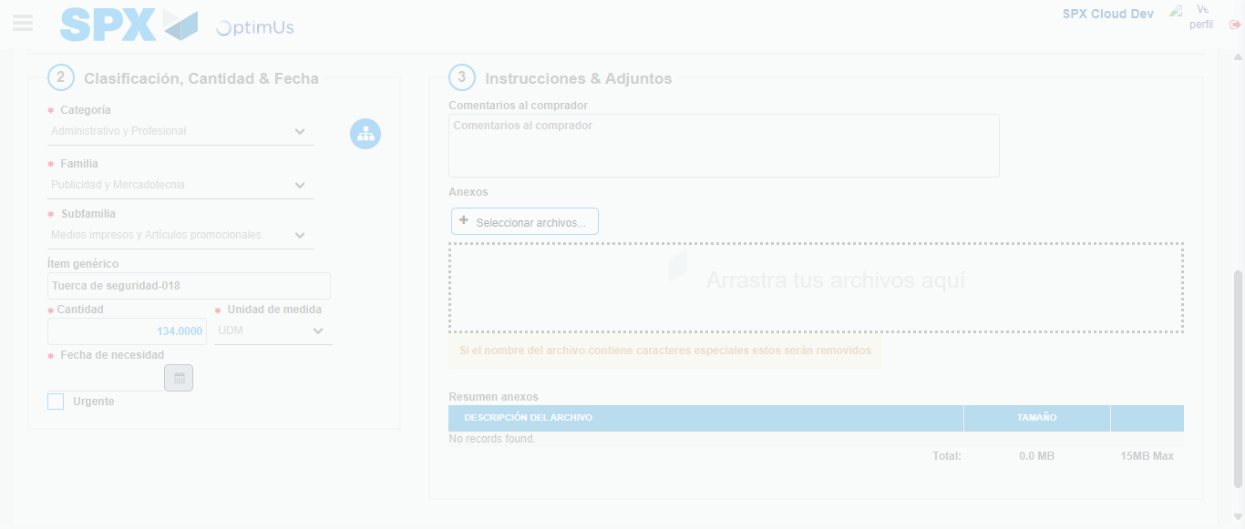Image file-name: QC_Testing-runTestMultipleTimes-nov. 25 2025, 03 54 35 p. m.

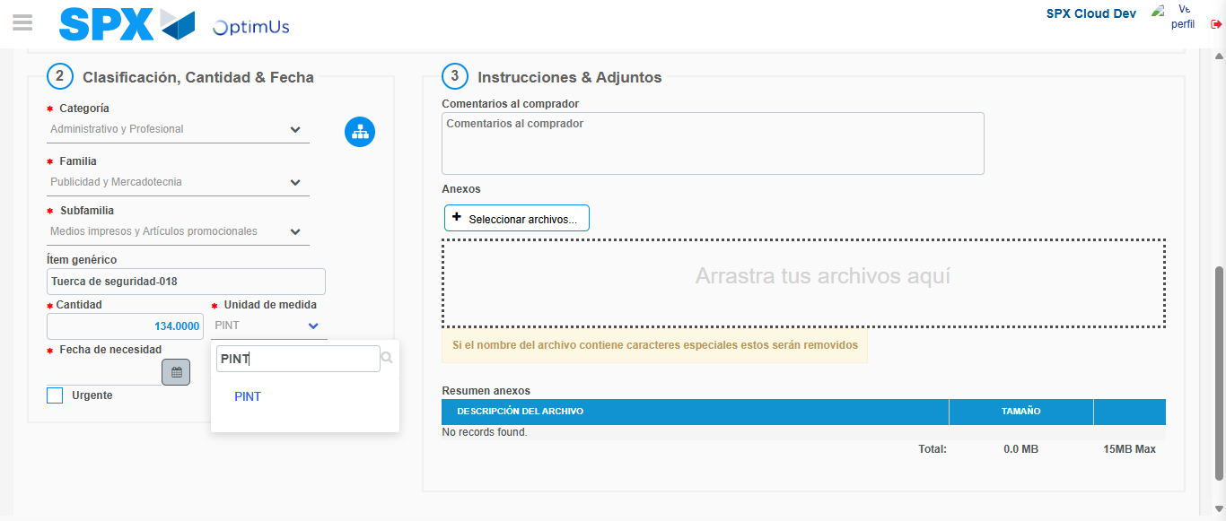Image file-name: QC_Testing-runTestMultipleTimes-nov. 25 2025, 03 54 36 p. m.

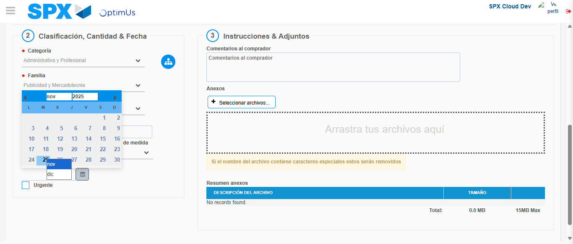Image file-name: QC_Testing-runTestMultipleTimes-nov. 25 2025, 03 54 37 p. m.

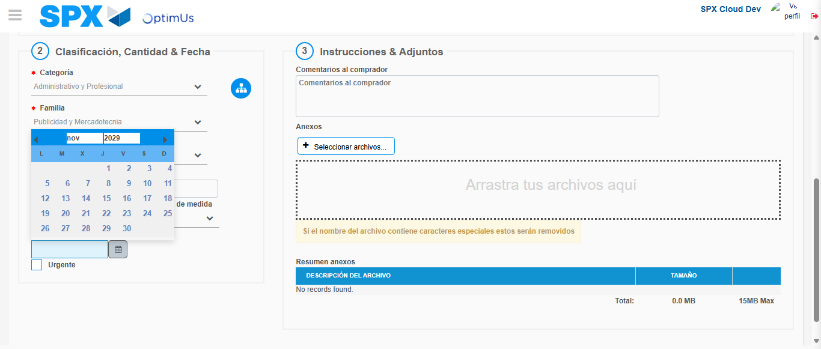Image file-name: QC_Testing-runTestMultipleTimes-nov. 25 2025, 03 54 38 p. m.

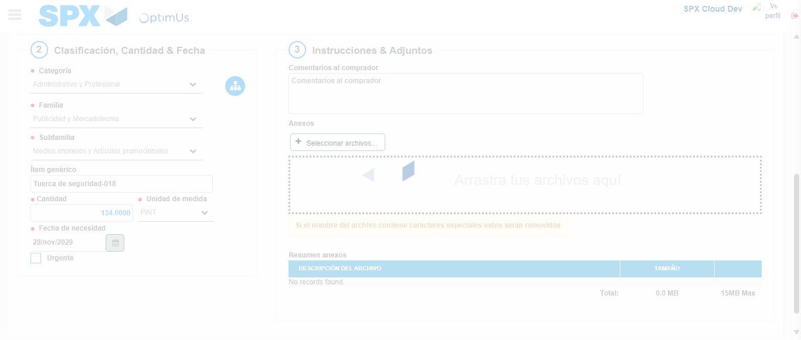Image file-name: QC_Testing-runTestMultipleTimes-nov. 25 2025, 03 54 39 p. m.

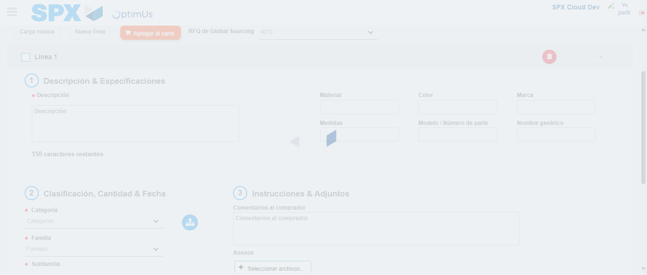Image file-name: QC_Testing-runTestMultipleTimes-nov. 25 2025, 03 54 40 p. m.

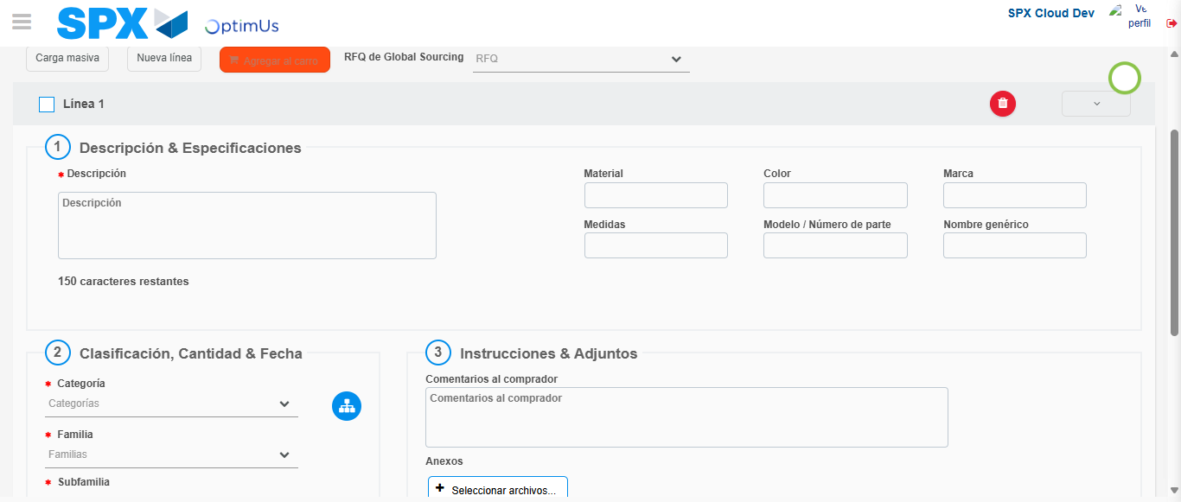Image file-name: QC_Testing-runTestMultipleTimes-nov. 25 2025, 03 54 41 p. m.

Image file-name: QC_Testing-runTestMultipleTimes-nov. 25 2025, 03 56 04 p. m.

Image file-name: QC_Testing-runTestMultipleTimes-nov. 25 2025, 03 56 05 p. m.

Image file-name: QC_Testing-runTestMultipleTimes-nov. 25 2025, 03 56 06 p. m.

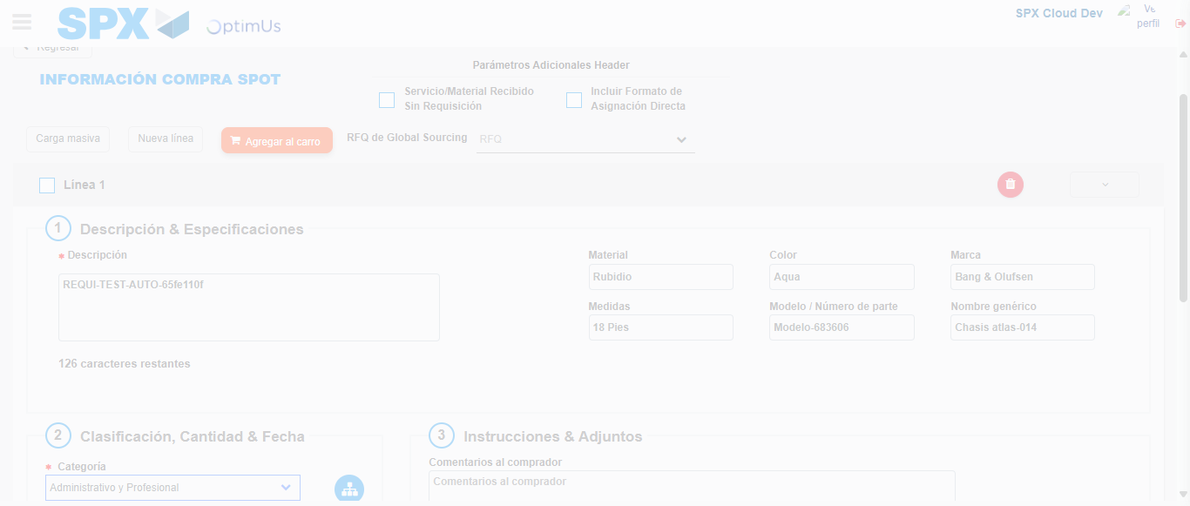Image file-name: QC_Testing-runTestMultipleTimes-nov. 25 2025, 03 56 07 p. m.

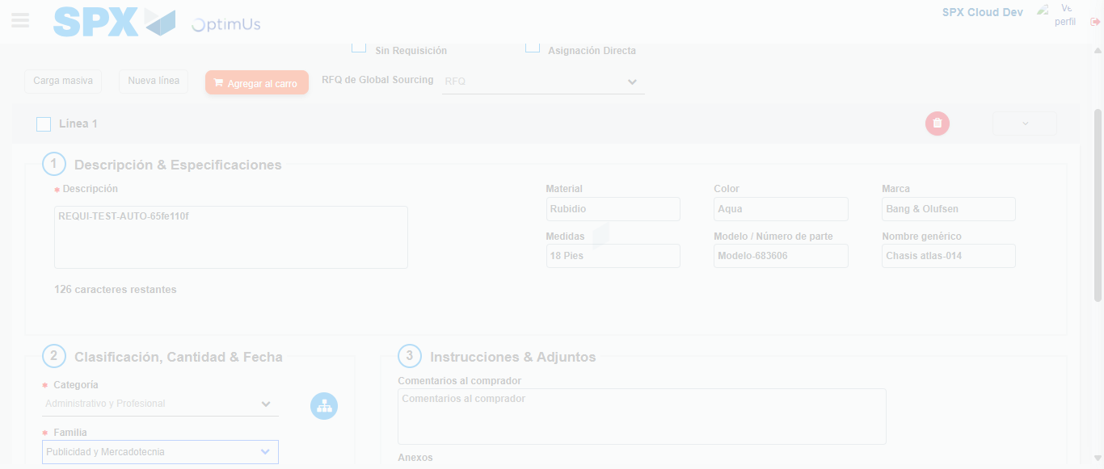Image file-name: QC_Testing-runTestMultipleTimes-nov. 25 2025, 03 56 08 p. m.

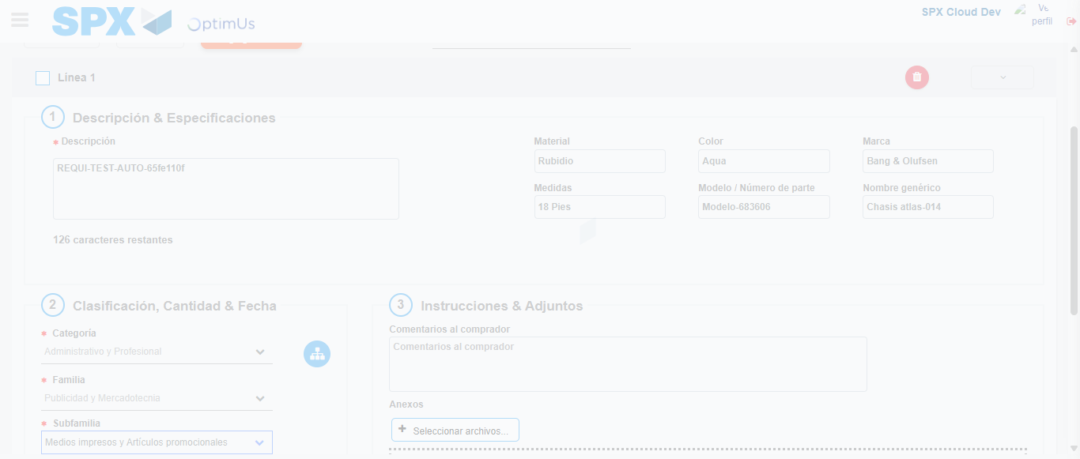Image file-name: QC_Testing-runTestMultipleTimes-nov. 25 2025, 03 56 09 p. m.

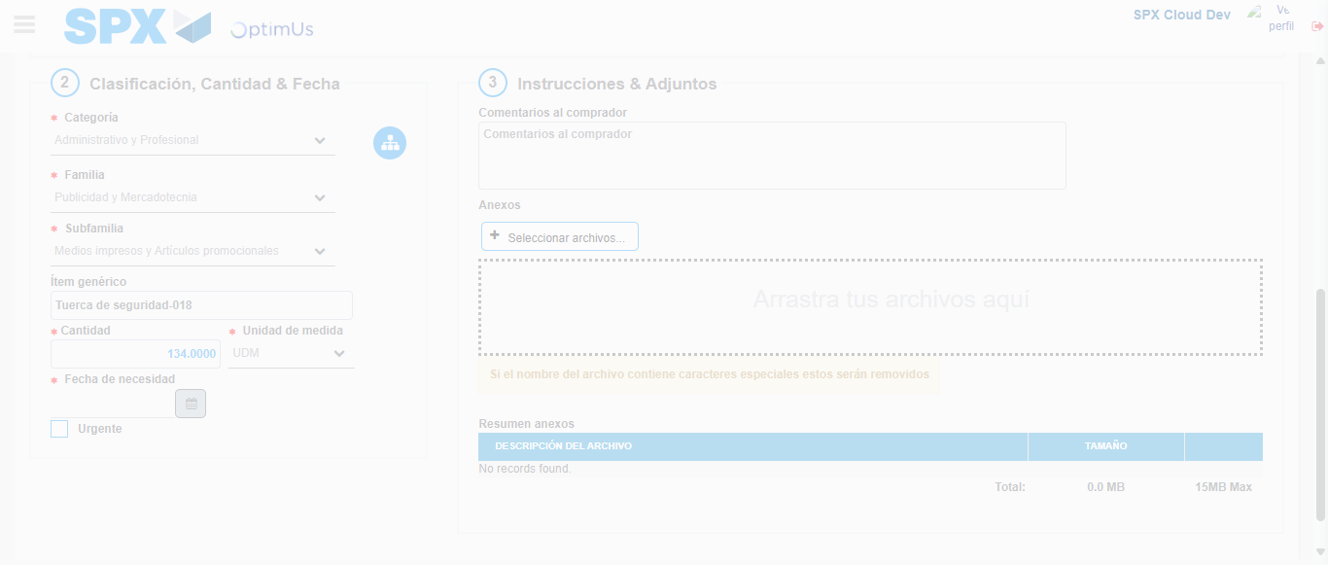Image file-name: QC_Testing-runTestMultipleTimes-nov. 25 2025, 03 56 10 p. m.

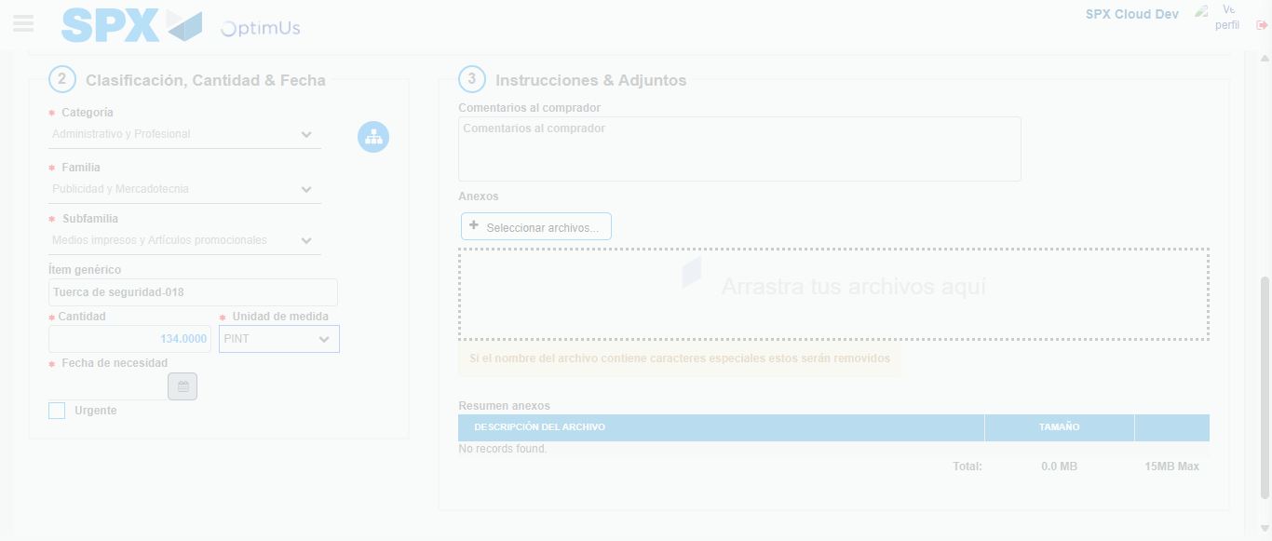Image file-name: QC_Testing-runTestMultipleTimes-nov. 25 2025, 03 56 11 p. m.

Image file-name: QC_Testing-runTestMultipleTimes-nov. 25 2025, 03 56 12 p. m.

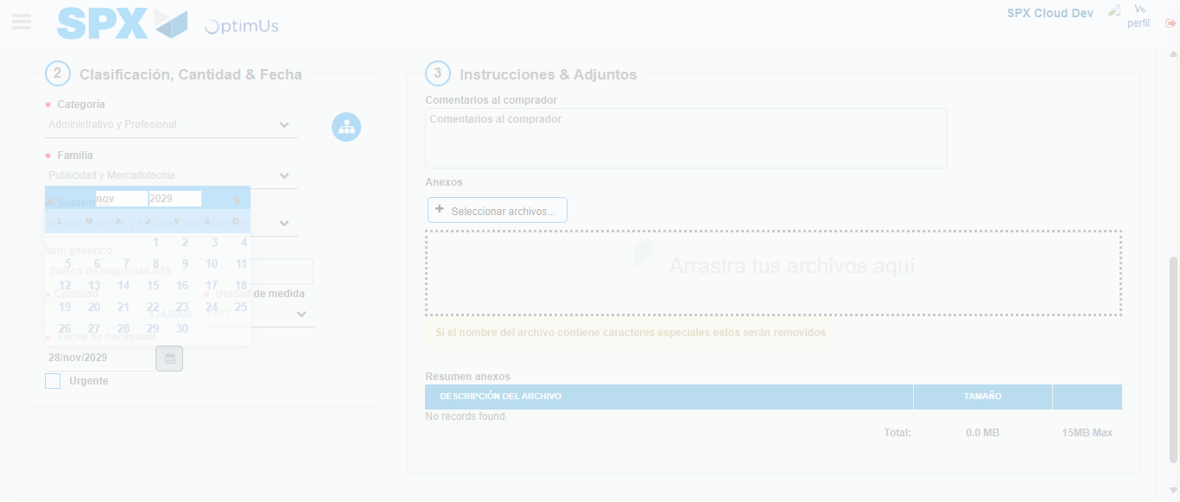Image file-name: QC_Testing-runTestMultipleTimes-nov. 25 2025, 03 56 13 p. m.

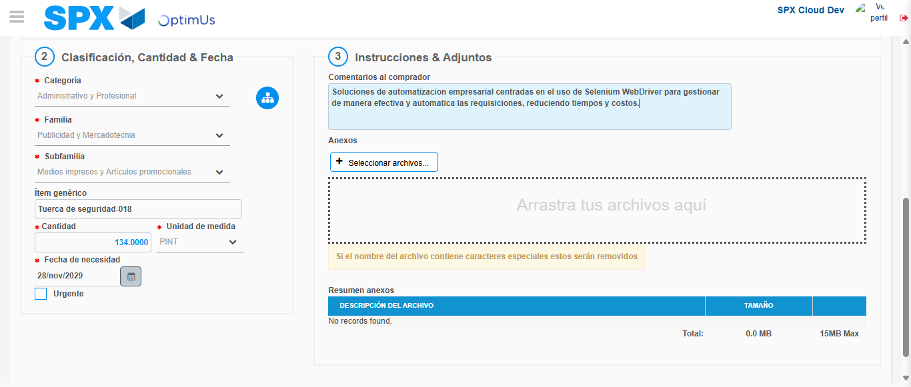Image file-name: QC_Testing-runTestMultipleTimes-nov. 25 2025, 03 56 14 p. m.

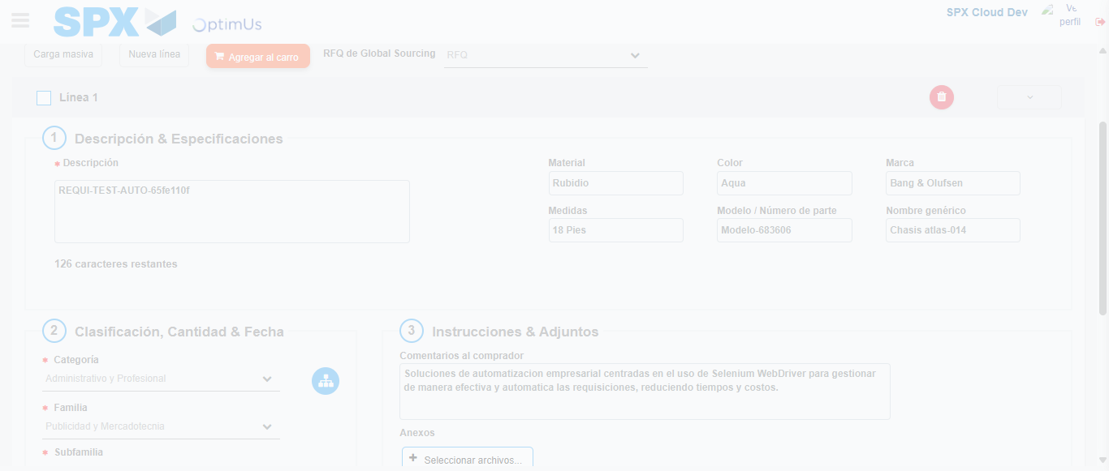Image file-name: QC_Testing-runTestMultipleTimes-nov. 25 2025, 03 56 15 p. m.

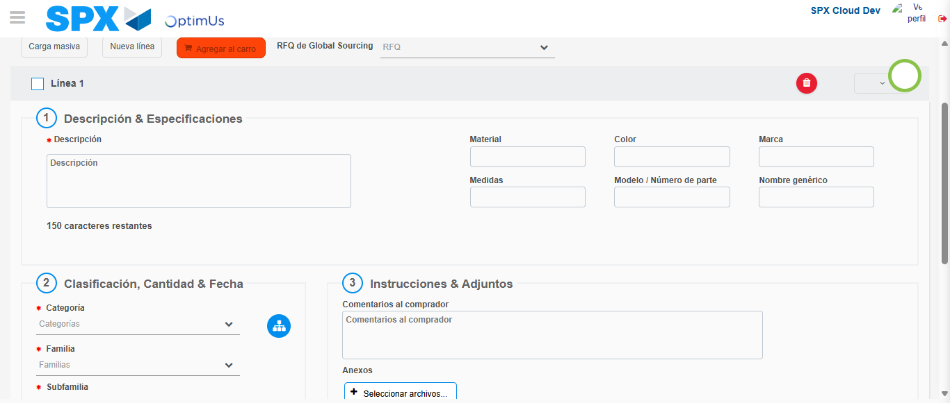Image file-name: QC_Testing-runTestMultipleTimes-nov. 25 2025, 03 56 16 p. m.

Step 4 - Select to Requisition : Requisition Correctly selected
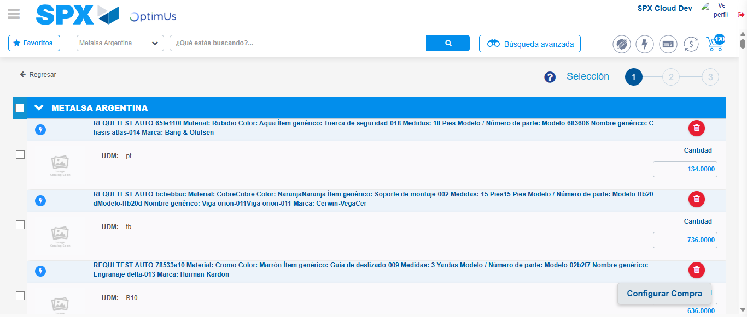Image file-name: QC_Testing-runTestMultipleTimes-nov. 25 2025, 03 55 01 p. m.

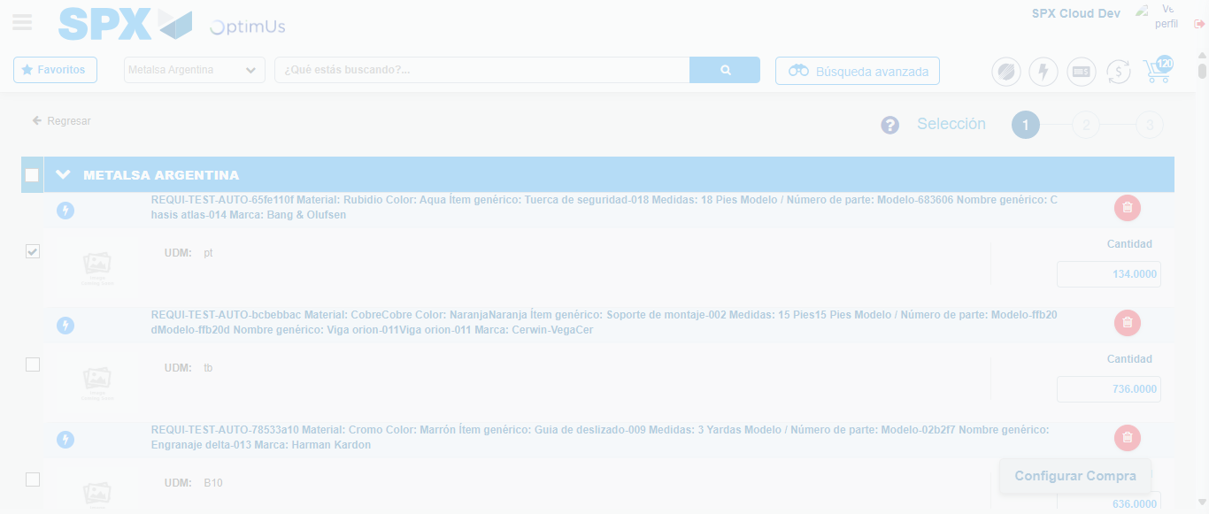Image file-name: QC_Testing-runTestMultipleTimes-nov. 25 2025, 03 55 02 p. m.

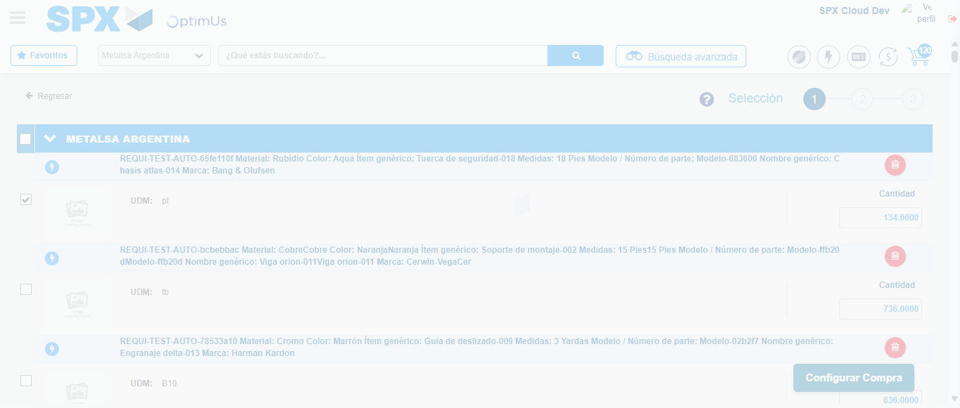Image file-name: QC_Testing-runTestMultipleTimes-nov. 25 2025, 03 55 05 p. m.

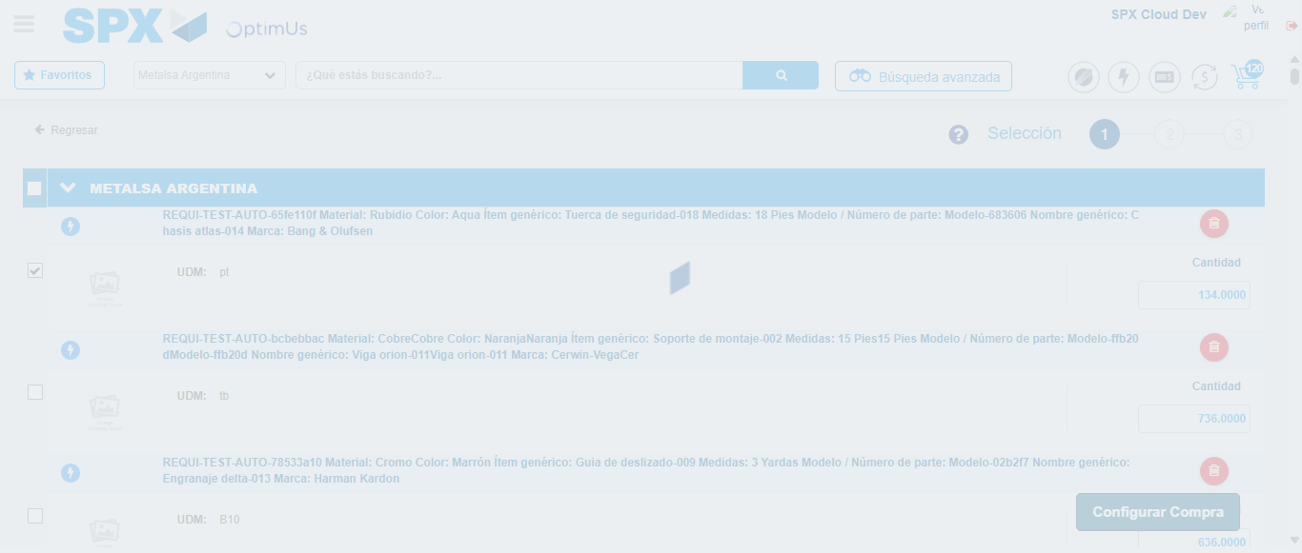Image file-name: QC_Testing-runTestMultipleTimes-nov. 25 2025, 03 55 06 p. m.

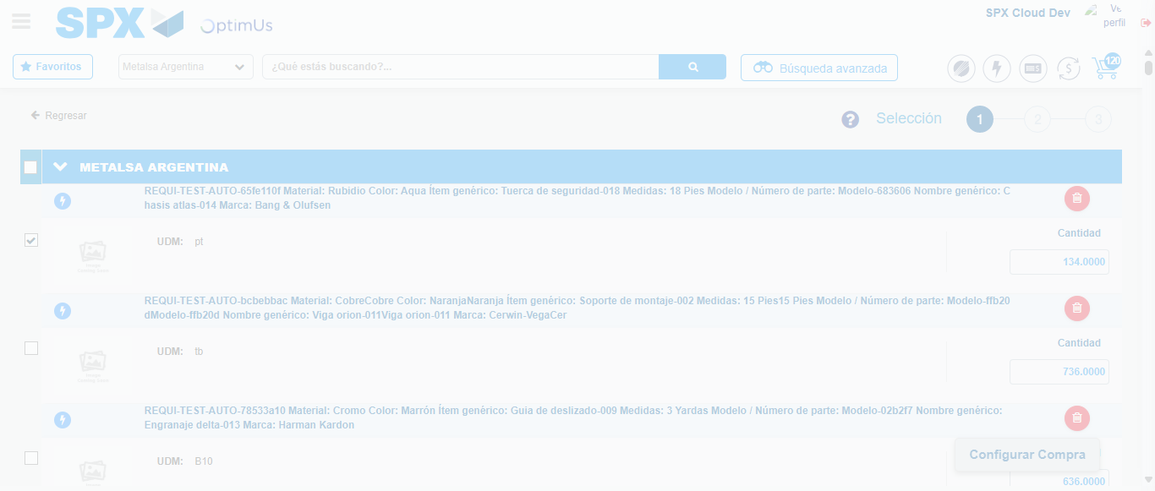Image file-name: QC_Testing-runTestMultipleTimes-nov. 25 2025, 03 56 24 p. m.

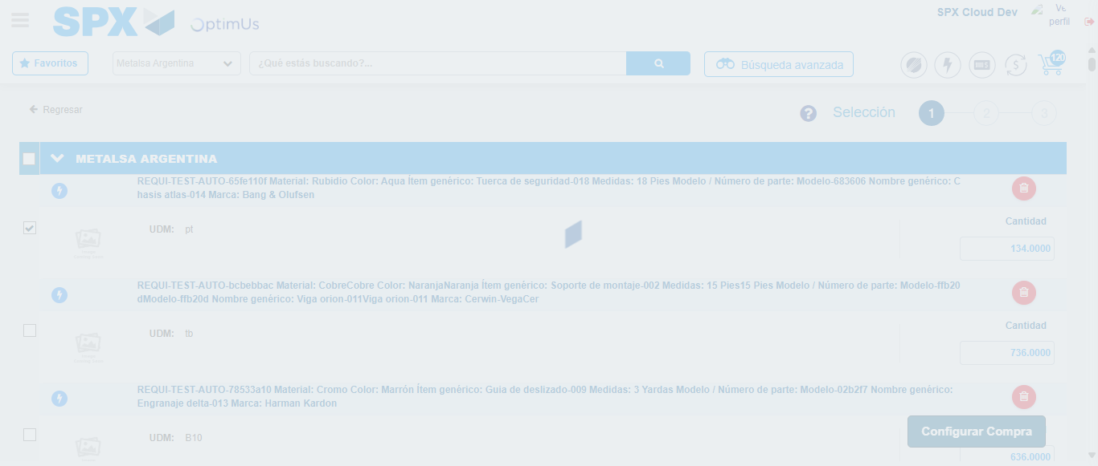Image file-name: QC_Testing-runTestMultipleTimes-nov. 25 2025, 03 56 28 p. m.

Step 5 - Select Type Account For Requisition : Type Account Correctly selected
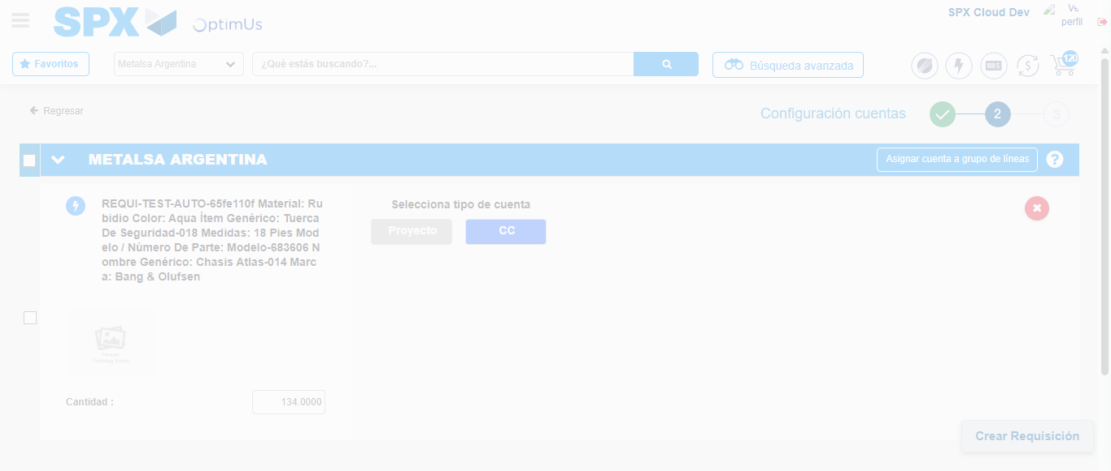Image file-name: QC_Testing-runTestMultipleTimes-nov. 25 2025, 03 55 08 p. m.

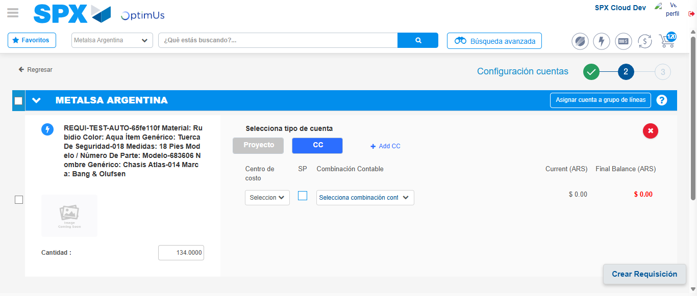Image file-name: QC_Testing-runTestMultipleTimes-nov. 25 2025, 03 55 11 p. m.

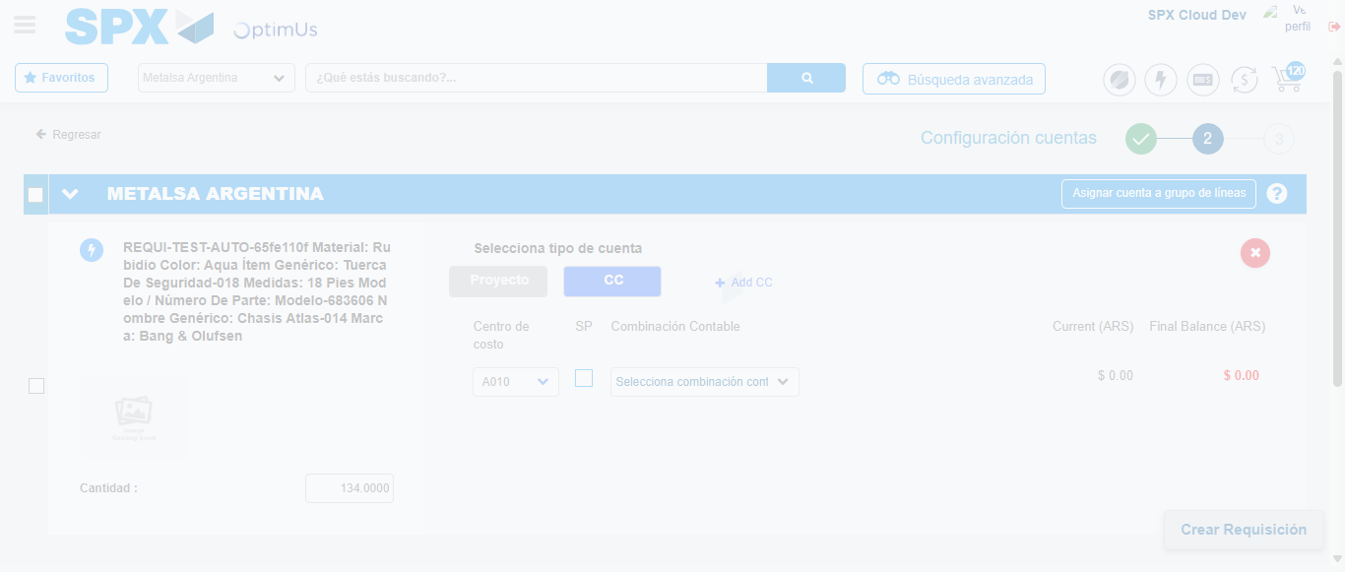Image file-name: QC_Testing-runTestMultipleTimes-nov. 25 2025, 03 55 15 p. m.

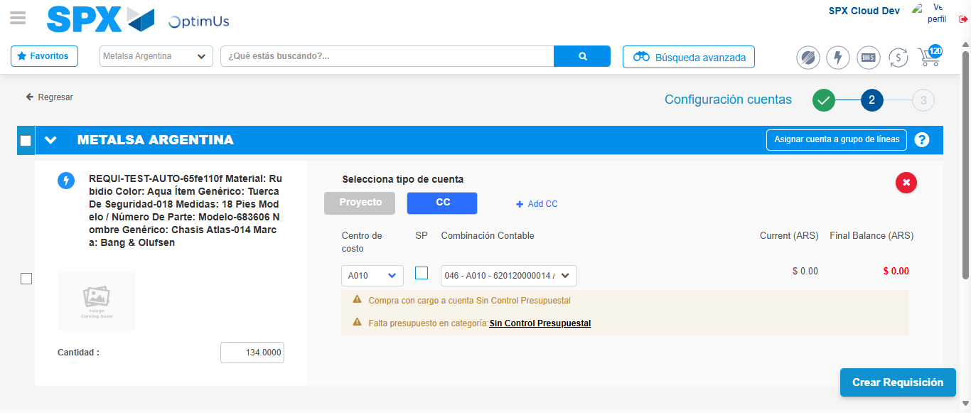Image file-name: QC_Testing-runTestMultipleTimes-nov. 25 2025, 03 55 18 p. m.

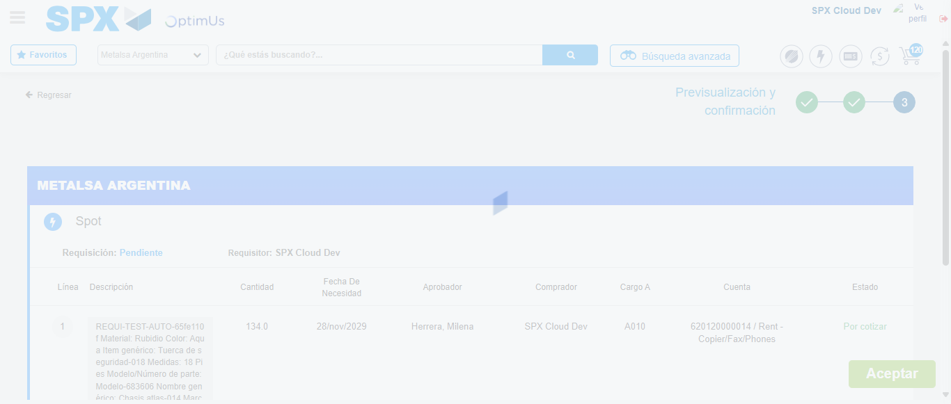Image file-name: QC_Testing-runTestMultipleTimes-nov. 25 2025, 03 55 19 p. m.

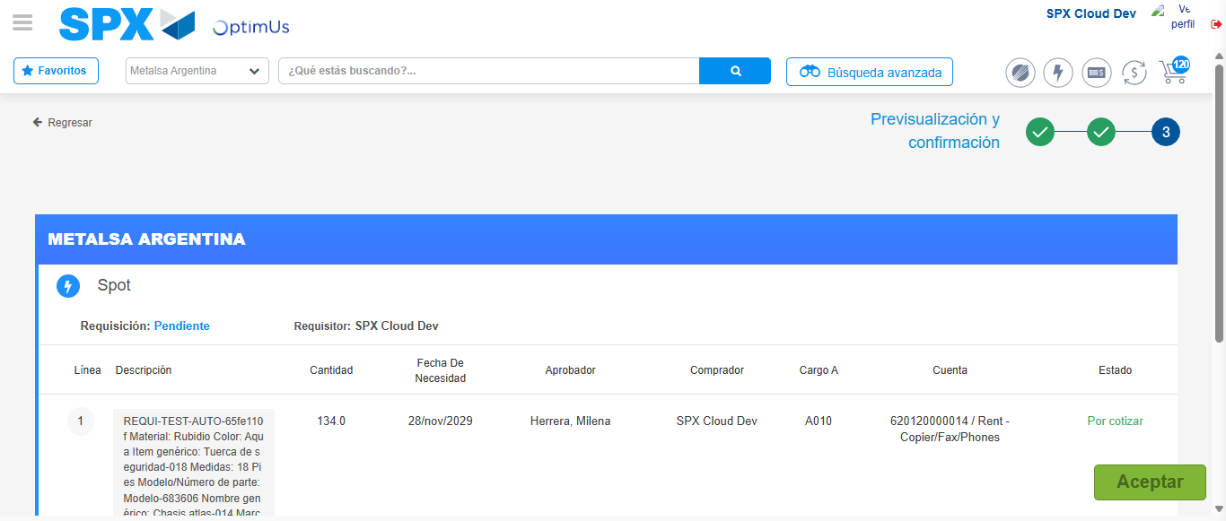Image file-name: QC_Testing-runTestMultipleTimes-nov. 25 2025, 03 55 22 p. m.

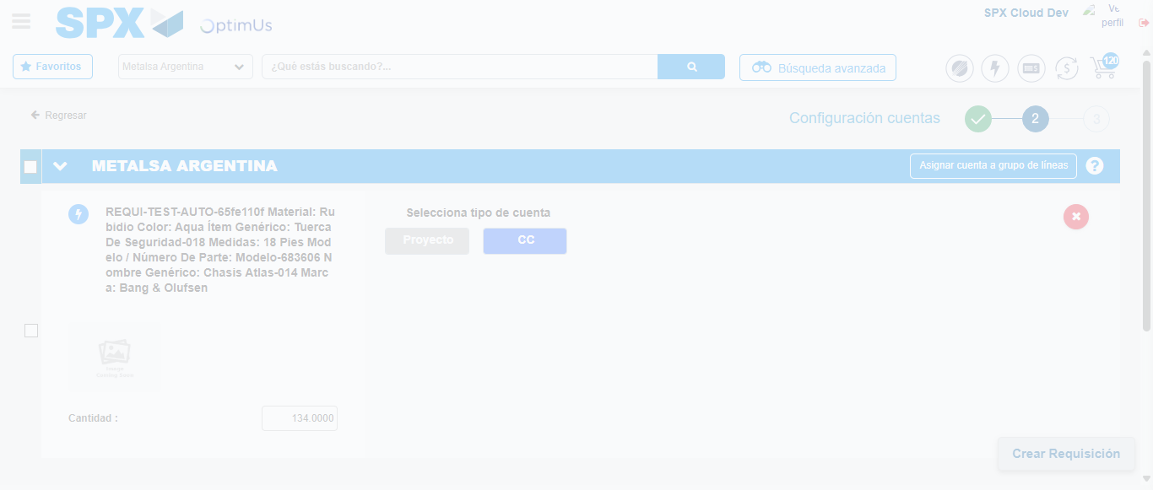Image file-name: QC_Testing-runTestMultipleTimes-nov. 25 2025, 03 56 31 p. m.

Image file-name: QC_Testing-runTestMultipleTimes-nov. 25 2025, 03 56 34 p. m.

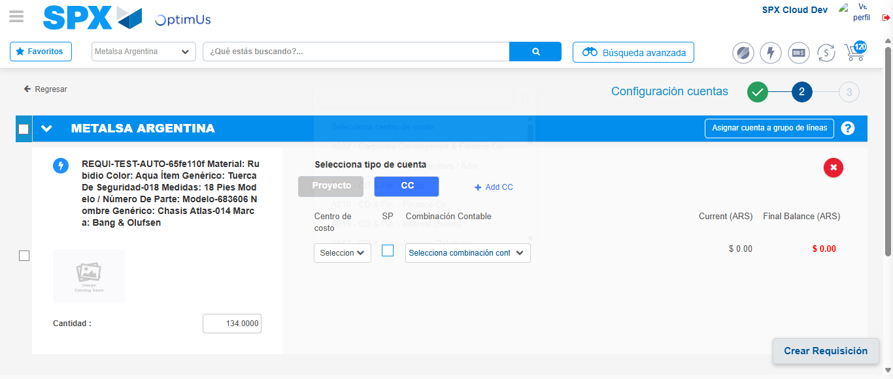Image file-name: QC_Testing-runTestMultipleTimes-nov. 25 2025, 03 56 37 p. m.

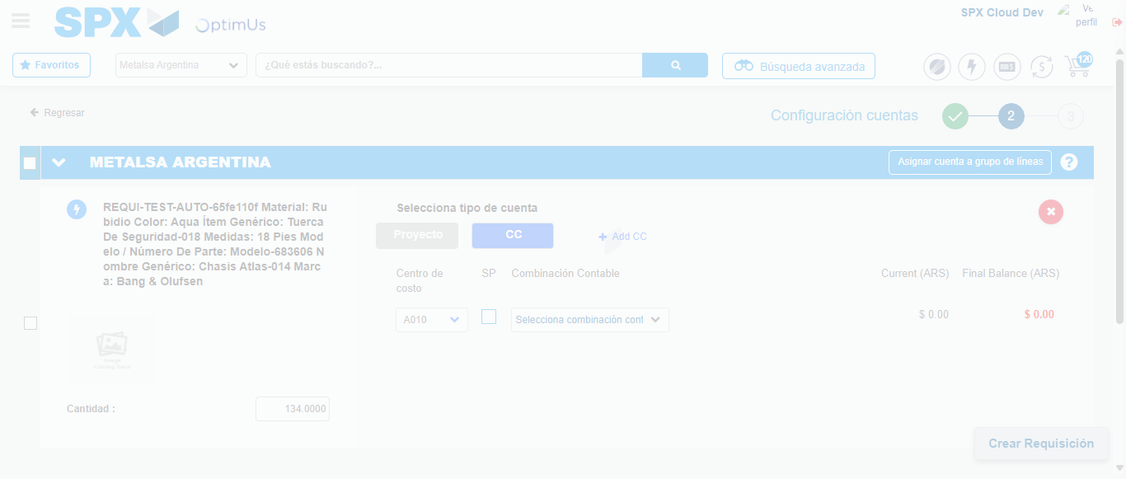Image file-name: QC_Testing-runTestMultipleTimes-nov. 25 2025, 03 56 38 p. m.

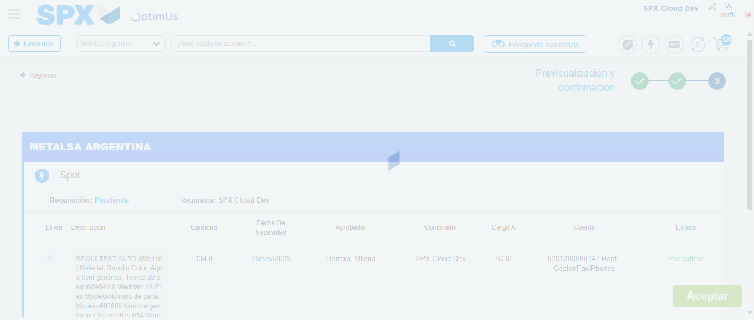Image file-name: QC_Testing-runTestMultipleTimes-nov. 25 2025, 03 56 41 p. m.

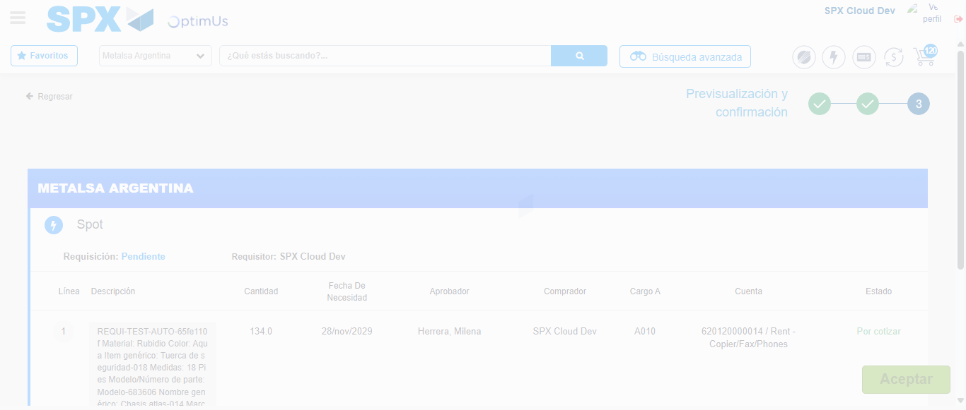Image file-name: QC_Testing-runTestMultipleTimes-nov. 25 2025, 03 56 45 p. m.

Step 6 - Accept to Requisition : Requisition Accepted
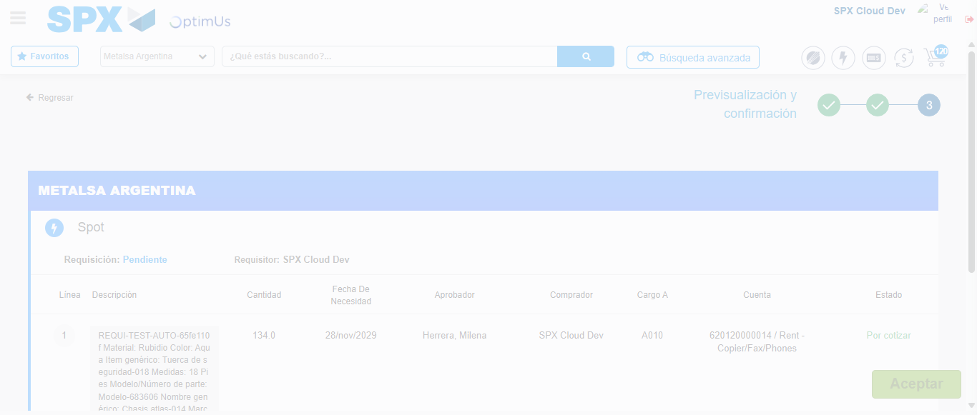Image file-name: QC_Testing-runTestMultipleTimes-nov. 25 2025, 03 55 23 p. m.

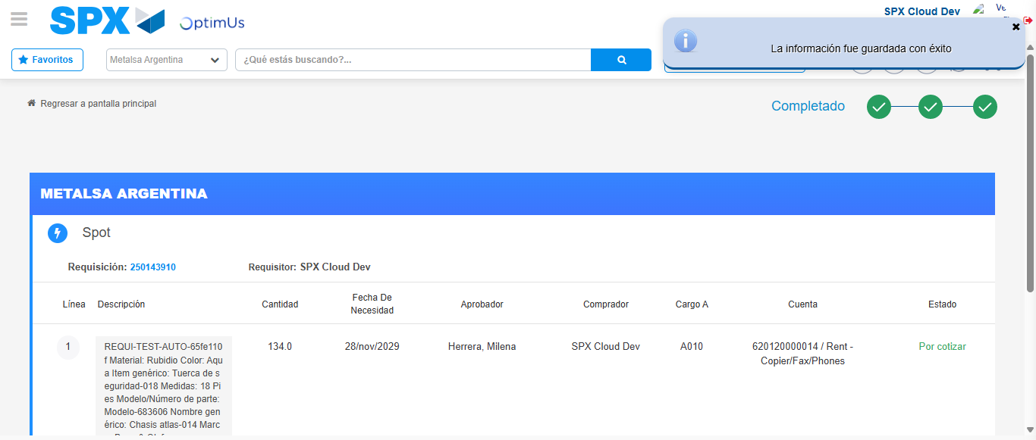Image file-name: QC_Testing-runTestMultipleTimes-nov. 25 2025, 03 55 26 p. m.

Image file-name: QC_Testing-runTestMultipleTimes-nov. 25 2025, 03 56 45 p. m.

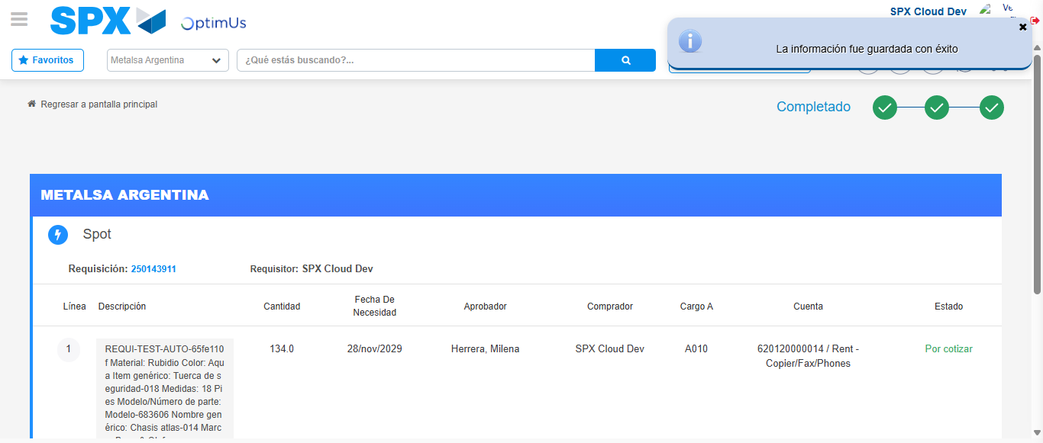Image file-name: QC_Testing-runTestMultipleTimes-nov. 25 2025, 03 56 49 p. m.

